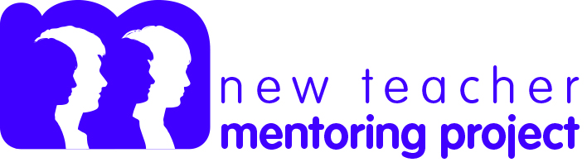

Event Design Process
Mentor/mentee workshop planning

Who’s coming? What expertise do they bring to the work?

Outcomes: What do you want mentors and mentees to know and be able to do as a result of this workshop? (Remember less is more.)

Content: What content is important to include in order to meet the outcomes?

Active learning: How will your participants interact with the content and process their learning? (Examples: Turn and talk, Give one/get one, teach back).

Agenda and pacing: How will you sequence and pace the workshop?

Adapted from:
16th National Symposium: Bring It On! Creating First Learning Experiences for New Mentors. Copyright ©2014 New Teacher Center. All Rights Reserved.

